**Lesson 3 Demo 2**

**Understanding the Working of Nodes**

**Objective:** To understand the working of nodes

**Tools required:** kubeadm

**Prerequisites:** A Kubernetes cluster should be set up (follow the steps of Lesson 1 Demo 1)

Steps to be followed:

1. Verify the status of a node
2. Delete a worker node
3. Register a worker node using a config file

**Step 1: Verify the status of a node**

1. List all the running nodes in a cluster

*kubectl get nodes*

1.2 Verify the status of the worker node:

*kubectl describe node <<nodename>>(worker-node1.example.com)*

|  |
| --- |
| **Note:** Replace <<nodename>> with the name of any worker node from step 1.1’s output. In this case, we have used node 1 with the name worker-node1.example.com. |

**Step 2: Delete a worker node**

1. Use the following command to delete a worker node:

kubectl delete node worker-node1.example.com

|  |
| --- |
| **Note:** Replace <<nodename>> with the name of any worker node from step 1.1  output. In this case, we have used a second node with the name worker-node1.example.com. |

2.2 Fetch the list of nodes in the cluster

kubectl get nodes

**Step 3: Register a worker node using a config file**

1. Create a file named nodereg.json and add the following code in it

vi nodereg.json

{

"kind": "Node",

"apiVersion": "v1",

"metadata": {

"name": "<<worker-node1.example.com>>",

"labels": {

"name": "firstnode"

}

}

}

|  |
| --- |
| **Note:** Replace <<nodename>> with the name of the deleted worker node from step 2.1’soutput. In this case, the node name is worker-node1.example.com. |

3.3 Run the following command to register the node using the nodereg.json file:

kubectl create -f ./nodereg.json

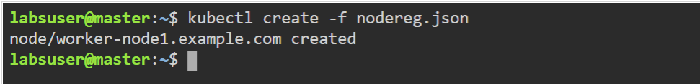

3.4 Write the following command to verify the created node:

kubectl get nodes

